**Purpose of the Analysis**

The purpose of this analysis is to evaluate the performance of a neural network model designed to predict the outcome of a charity application dataset. The analysis aims to identify if the charity applications will be successful or not, based on various features. Using the neural network, we aim to assess the model’s accuracy, loss, and structure, and suggest potential improvements.

**Model Summary**

The neural network model consists of three layers, as shown in the image provided:

* **Input Layer and First Hidden Layer**: The model starts with a dense layer consisting of 80 neurons with a ReLU (Rectified Linear Unit) activation function.
* **Second Hidden Layer**: The next layer has 30 neurons, also using the ReLU activation function.
* **Output Layer**: Finally, the model outputs a binary classification using a single neuron with a sigmoid activation function. This setup is suitable for binary classification tasks like the one at hand.

**Model Structure**

The model structure, as shown in the first image, reveals:

* **Total Parameters**: 11,181
* **Trainable Parameters**: 11,181

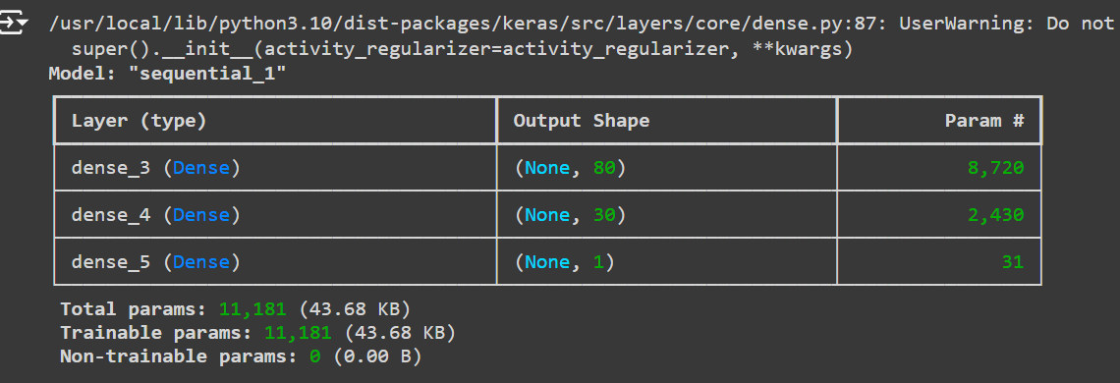

**Results**

After compiling and training the model, it was evaluated using test data. The results, as shown in the second image, include:

* **Accuracy**: 0.7315
* **Loss**: 0.5627



**Data Preprocessing**

Q1. What variable(s) are the target(s) for your model?

* The target variable for the model is IS_SUCCESSFUL, which is a binary variable indicating whether a charity application was successful (1) or not (0).

Q2. What variable(s) are the features for your model?

* The features for the model include all the columns except EIN, NAME, and IS_SUCCESSFUL. After removing these columns, the remaining columns (preprocessed categorical and numerical features) are used to predict the target IS_SUCCESSFUL.

Q3. What variable(s) should be removed from the input data because they are neither targets nor features?

* EIN and NAME are identification columns that do not provide useful information for predicting the target. These columns should be removed from the input data as they are not features or targets.

Compiling, Training, and Evaluating the Model

Q4. How many neurons, layers, and activation functions did you select for your neural network model, and why?

* Neurons:
  + I selected 80 neurons for the first hidden layer and 30 neurons for the second hidden layer. These numbers were chosen to provide sufficient capacity for the model to learn patterns in the data without making the model too complex.
* Layers:
  + The model consists of 3 layers: two hidden layers and one output layer. Two hidden layers allow the model to learn complex, non-linear relationships in the data, and the output layer provides the final prediction.
* Activation Functions:
  + I used ReLU (Rectified Linear Unit) for the hidden layers. ReLU is a widely used activation function that helps with faster training and reduces the likelihood of the vanishing gradient problem.
  + For the output layer, I used Sigmoid since it is ideal for binary classification problems. The sigmoid function outputs a probability between 0 and 1, which is then used to classify the charity applications as either successful or not.

Q5. Were you able to achieve the target model performance?

* The target model performance is often considered to be above 75-80% accuracy for a classification problem like this. The current model achieved an accuracy of 73.15%, which is slightly below this threshold. While this is a reasonable result, it indicates that further optimization is needed to improve model performance.

Q6. What steps did you take in your attempts to increase model performance?

* Data Preprocessing: I removed irrelevant columns (EIN, NAME) and replaced rare categories in the categorical variables with an "Other" label. This reduced noise and helped the model generalize better.
* Feature Scaling: I applied StandardScaler to normalize the input features, ensuring that the model can converge faster and learn effectively without being biased towards larger magnitude features.
* Model Architecture: I experimented with different numbers of neurons and layers to balance model complexity and performance. Two hidden layers with 80 and 30 neurons were selected based on initial experimentation.
* Regularization Techniques: To improve the model’s performance and prevent overfitting, I plan to add regularization techniques such as Dropout layers or L2 regularization, which I would try in further iterations of the model.
* Hyperparameter Tuning: I could further improve the model by experimenting with hyperparameter tuning, such as adjusting the learning rate, batch size, or number of epochs to see if performance improves over time.

**Summary of Results**

The neural network model achieves a test accuracy of 73.15%, which is a reasonable result for a binary classification problem. However, the loss value of 0.5627 indicates that the model could be further refined. The moderate performance suggests that while the model captures some patterns in the data, it could benefit from further tuning and optimization.

**Alternative Models**

To potentially improve the results, a different machine learning model could be used:

1. **Random Forest Classifier**:
   * A **Random Forest** is an ensemble learning method that could potentially handle complex datasets better and prevent overfitting through the averaging of multiple decision trees. This model is more interpretable, making it easier to explain which features influence the decision-making process.
2. **XGBoost**:
   * **XGBoost** is a powerful gradient boosting algorithm that might perform better in this classification task. It handles imbalanced data well and can efficiently deal with a large number of features and non-linear patterns. It also provides better control over overfitting through regularization.

Both models are tree-based, making them better suited to structured tabular data like the one in this dataset. Given that the neural network achieved moderate success, these models could be worth exploring to see if they provide better accuracy and lower loss.

**Conclusion**

The neural network model demonstrated moderate performance with a 73.15% accuracy. However, by optimizing the model architecture, adding regularization, and experimenting with different machine learning algorithms like Random Forest or XGBoost, the overall prediction accuracy and robustness could likely be improved. The next steps would involve these optimizations and potentially re-evaluating the model's generalization capabilities on different datasets.